**Simple Query MySQL(Bagian 2) :**

1. SELECT * FROM `stok_masuk` ORDER BY harga DESC
2. SELECT * FROM `stok_masuk` ORDER BY stok_masuk ASC
3. SELECT * FROM `nama_produk` WHERE izin_bpom LIKE '%aa%'
4. SELECT * FROM `stok_masuk` WHERE id_nama_produk <= 7 ORDER BY id_penanggung_jawab DESC
5. SELECT `id_nama_produk`, SUM(`stok_masuk`) AS total FROM `stok_masuk` GROUP BY `id_nama_produk`
6. SELECT `id_penanggung_jawab`, SUM(`stok_masuk`) AS Total_stok FROM `stok_masuk` GROUP BY `id_penanggung_jawab`
7. SELECT `tanggal_stok_masuk`, SUM(`stok_masuk`) AS total_stok FROM `stok_masuk` GROUP BY `tanggal_stok_masuk`
8. SELECT `tanggal_stok_masuk`, SUM(`stok_masuk`) AS total_stok FROM `stok_masuk` GROUP BY `tanggal_stok_masuk` ORDER BY SUM(`stok_masuk`) DESC
9. SELECT `id_penanggung_jawab`, SUM(`stok_masuk`) AS Total_stok FROM `stok_masuk` GROUP BY `id_penanggung_jawab` ORDER BY SUM(`stok_masuk`) ASC
10. SELECT * FROM `nama_produk` WHERE `perusahaan_farmasi` LIKE '%Obat tua%' ORDER BY `nama_produk` ASC

**Hasil ScreenShot :**

1. SELECT * FROM `stok_masuk` ORDER BY harga DESC

1. SELECT * FROM `stok_masuk` ORDER BY stok_masuk ASC

1. SELECT * FROM `nama_produk` WHERE izin_bpom LIKE '%aa%'

1. SELECT * FROM `stok_masuk` WHERE id_nama_produk <= 7 ORDER BY id_penanggung_jawab DESC

1. SELECT `id_nama_produk`, SUM(`stok_masuk`) AS total FROM `stok_masuk` GROUP BY `id_nama_produk`

1. SELECT `id_penanggung_jawab`, SUM(`stok_masuk`) AS Total_stok FROM `stok_masuk` GROUP BY `id_penanggung_jawab`

1. SELECT `tanggal_stok_masuk`, SUM(`stok_masuk`) AS total_stok FROM `stok_masuk` GROUP BY `tanggal_stok_masuk`

1. SELECT `tanggal_stok_masuk`, SUM(`stok_masuk`) AS total_stok FROM `stok_masuk` GROUP BY `tanggal_stok_masuk` ORDER BY SUM(`stok_masuk`) DESC

1. SELECT `id_penanggung_jawab`, SUM(`stok_masuk`) AS Total_stok FROM `stok_masuk` GROUP BY `id_penanggung_jawab` ORDER BY SUM(`stok_masuk`) ASC

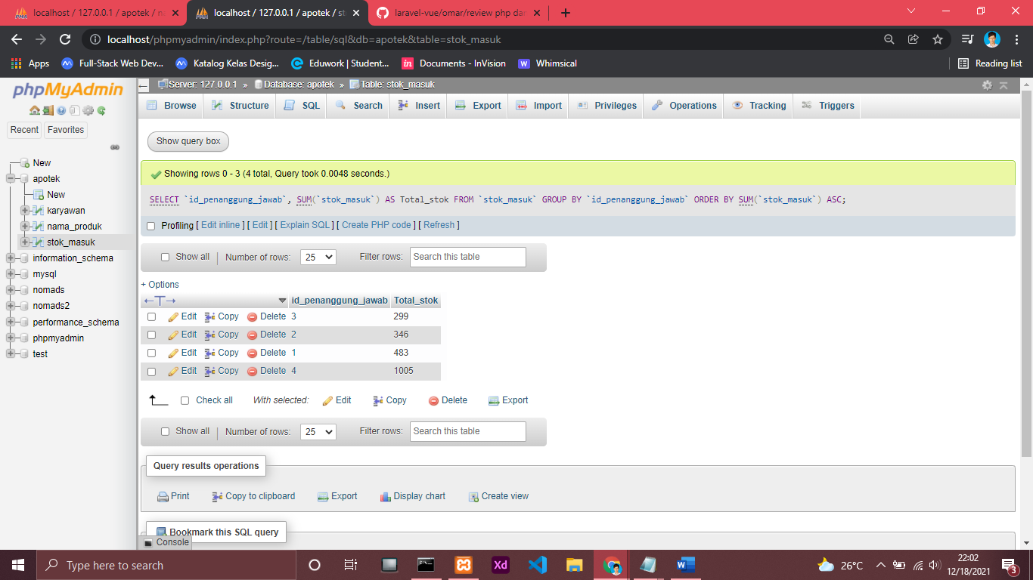

1. SELECT * FROM `nama_produk` WHERE `perusahaan_farmasi` LIKE '%Obat tua%' ORDER BY `nama_produk` ASC

